JRS CHILD DEVELOPMENT CENTER AND ACADEMY
KINDERGARTEN
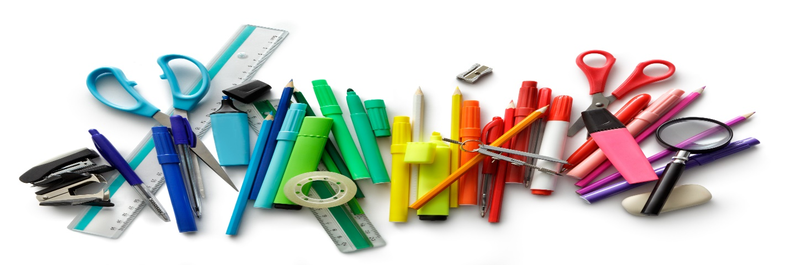
SUPPLY LIST
(2) Regular Packs of Crayola Crayons | Backpack (no wheels)
(10) My First Ticonderoga Pencils (Jumbo) | (1) White or Colored Cardstock
(2) 1” Binders with clear pockets on the front and back | (1) Pencil Pouches
(2) Primary Composition Notebooks (with picture drawing section) | (1) Crayon Box
Colored Pencils | Sheet Protectors (25 pack)
(4) Elmer’s Glue Stick | 2 Big Pink Erasers/ pack of pencils
2nd Uniform (Change of clothes labeled in Ziploc bag) | - Pack of Expo Dry-erase markers
(2) Plastic Folders w/ Holes | (1) Scissors
- Large box of quart-sized Ziploc bags | - Large box of gallon-sized Ziploc bags
- Large boxes of Kleenex/ Puffs | - Clorox Wipes (Large container)
- Bottles of Hand Sanitizer | - Roll of Paper Towels
Classroom Snacks (at least 20 students) | - Lysol Spray
- Bottles of Hand Soap | Headphones for Chromebook
JRS CHILD DEVELOPMENT CENTER AND ACADEMY
1st GRADE
SUPPLY LIST

18ct Crayola Crayon | (3) Packs of Ticonderoga Brand Pencils
#2 Pencils (pre-sharpened) | (2) Composition Notebooks
(1) Chair Back Buddy (Amazon) | (3) small packs of index cards
Backpack (no wheels) | (1)White or Colored Cardstock
(1) Pencil Pouches | Sheet Protectors (25 pack)
Subject Dividers (5 pack) | Pack of Pencil Erasers
(1)Pack of Expo Dry-Erase Markers | (1)Ream of Copy Paper
(2) Pair of scissors | 2’’ Loose Leaf Binder Rings
(4) Glue sticks | (1) Large box of quart–size Ziploc bags
(1) Large box of gallon-sized Ziploc bags | (3) Clorox Wipes (Large container)
(3) Boxes of Kleenex/ Puffs | (3) Bottles of Hand Sanitizer
(3) Rolls of Paper towels | (2) Cans of Lysol Spray
Classroom snacks (No peanut projects) | (5) Packs of paper
(1) Headphones for Chromebooks

JRS CHILD DEVELOPMENT CENTER AND ACADEMY
2nd GRADE
SUPPLY LIST

1 KJV Bible | 3 Packages of wide-Ruled notebook paper
2 medium bottles of hand sanitizer | 1 dry erase board with markers (board should fit inside desk)
2 large rolls of paper towels | 1 package of washable markers
2 large boxes of Kleenex | 1 small headphones for Chromebooks
2 containers of disinfecting wipes | 2 green plastic folders with pockets
4 giant Elmer’s glue sticks | 2 red plastic folders with pockets
1 pair of Fiskars Safety scissors | 1 box of Ziploc bags (gallon-boys) OR (sandwich-girls)
1 package of #2 Ticonderoga lead pencils (sharpened) | 1 large package of individually wrapped fun-size candy (NO NUTS)
1 pencil box | 3 Cans of Lysol Spray
1 package of pencil top erasers | 1 – 5 pack black expo markers
1 package of pencil pals | 2 Highlighters
1 small fabric pencil pouch (for crayons) | 1 One Inch Binder
2 packs of 24 count Crayola crayons or Twistables | 1 Clipboard
1 – 12-inch ruler with inches and centimeters

JRS CHILD DEVELOPMENT CENTER AND ACADEMY
3RD GRADE
SUPPLY LIST
- Pair of Scissors | - Pack of Glue Sticks
- Ruler with centimeters and inches | - Pack of Markers
- Pack of Crayons | - Pack of Red Pens
- Pack of Colored Pencils | (4) Packs of Expo Markers
- Highlighter | (3) Rolls of Paper Towels (class collection)
(3) Boxes of Kleenex (class collection) | (1) Pack of Loose-Leaf Binder Rings
(8) Packs of Pencils | (1) 1-inch Binder
(1) Personal Pencil Sharpener with a collection container | (1) Pack of Subject Dividers
- Composition Books | (1) Zippered pencil pouch (no boxes)
(6) Packs of small index cards | (5) packs of Wide Rule Paper
(2) Packs of Colored Cardstock | (1) Pack of White Cardstock
- Cans of Lysol Spray | (2) Hand Sanitizer
(5)Containers of Clorox wipes | (Class Snacks (No peanut products)
(1) Black storage crate | * Headphones for Chromebook

JRS CHILD DEVELOPMENT CENTER AND ACADEMY
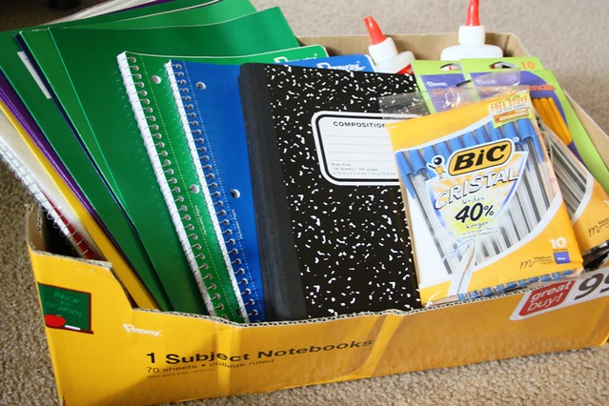
4th GRADE SUPPLY LIST

4 packages of 200ct. loose leaf paper (Wide Ruled)
3 college-ruled notebooks (writing assignments)
8 Folders w/pockets
2 packs of index cards
5 boxes of #2 pencils Ticonderoga brand
1 box of Crayola colored pencils (12 count)
1 box of Crayola markers (8 count)
1 zippered pouch (to put glue, erasers, scissor, pencils)
1 backpack (no wheels please)
4 large boxes of Puffs (facial tissue)
1 box of disinfectant wipes
2 bottles of Lysol Spray
1 bottle of hand sanitizer
Highlighters
4 Expo dry erase markers
1 2inch binder
1 Ruler
1 ream of white Xerox paper
2 multicolored card stock
Calculator
Protractor
Headphones for Chromebook
JRS CHILD DEVELOPMENT CENTER AND ACADEMY
5th GRADE
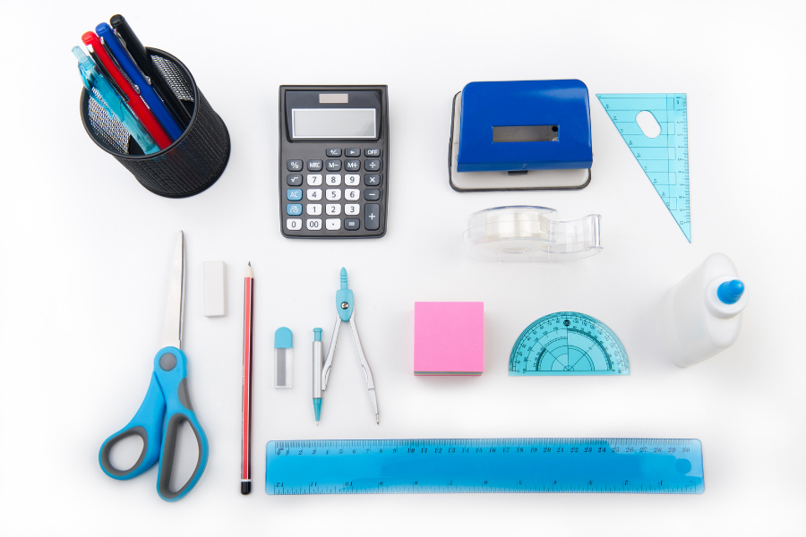
SUPPLY LIST
Loose Leaf Paper – 5 Packs
Pencils – 5 boxes (Ticonderoga)
Crayola Markers
Crayola Color Pencils
Scissors
Erasers – 4 packs
Large Pink Erasers
Ruler
Lysol/Clorox Wipes – 3 pack
Lysol Spray (1)
Sanitizer – 2 bottles
Kleenex – 5 boxes (Per Semester)
Folders w/Pockets – 8 (No Prongs)
White 2-inch Binder
Dividers (for Notebook)
Ream of multi-colored and white copy paper (1 each)
Highlighters
Expo Board Cleaner
Expo Dry Erase Markers
Storage Crate
Ziploc Bags – Gallon and Quart (1 each)
Protractor
Calculator
2 Composition Notebooks
1 pack of glue sticks
Headphones for Chromebook

